A PROJECT REPORT

on

“FAKE NEWS DETECTION”

Submitted to

KIIT Deemed to be University

In Partial Fulfillment of the Requirement for the Award of

BACHELOR’S DEGREE IN

COMPUTER SCIENCE AND ENGINEERING

BY

SAYANTANI CHAKRABORTY
URBI DAS

21051929
21052802

UNDER THE GUIDANCE OF

ABINAS PANDA



SCHOOL OF COMPUTER ENGINEERING

KALINGA INSTITUTE OF INDUSTRIAL TECHNOLOGY

BHUBANESWAR, ODISHA - 751024

March 2024

A PROJECT REPORT

on

“FAKE NEWS DETECTION”

Submitted to

KIIT Deemed to be University

In Partial Fulfillment of the Requirement for the Award of

BACHELOR’S DEGREE IN COMPUTER SCIENCE AND ENGINEERING

BY

SAYANTANI CHAKRABORTY URBI DAS

21051929
21052802

UNDER THE GUIDANCE OF

ABINAS PANDA

SCHOOL OF COMPUTER ENGINEERING

KALINGA INSTITUTE OF INDUSTRIAL TECHNOLOGY

BHUBANESWAR, ODISHA -751024

March 2024

KIIT Deemed to be University

School of Computer Engineering
Bhubaneswar, ODISHA 751024

CERTIFICATE

This is certify that the project entitled

“FAKE NEWS DETECTION”

submitted by

SAYANTANI CHAKRABORTY URBI DAS

21051929

21052802

is a record of bonafide work carried out by them, in the partial fulfillment of the requirement for the award of Degree of Bachelor of Engineering (Computer Sci-ence & Engineering OR Information Technology) at KIIT Deemed to be university, Bhubaneswar. This work is done during year 2023-2024, under our guidance.

Date: 30/03/2024

Abinas Panda
Project Guide

Acknowledgments

We are profoundly grateful to Abinas Panda of KIIT Deemed to be University
for his expert guidance and continuous encouragement throughout to see that this project rights its target since its commencement to its completion.

SAYANTANI CHAKRABORTY
URBI DAS

ABSTRACT

The proliferation of fake news across various platforms has emerged as a pressing societal issue, with far-reaching consequences including social discord and the erosion of trust among communities. In response, significant research efforts have been directed towards combating the spread of misinformation through the development of machine learning-based classification systems. In this study, we employ Python-based machine learning techniques to address this challenge, focusing on the classification of news articles into real and fake categories. By leveraging advanced natural language processing (NLP) methods and robust machine learning algorithms, we aim to develop an effective framework for identifying and mitigating the dissemination of fake news, thereby safeguarding the integrity of public discourse and fostering greater societal cohesion. Through systematic data preprocessing, insightful analysis, and rigorous model training and evaluation, our study contributes to the ongoing efforts to combat the proliferation of fake news and promote a healthier information ecosystem in the digital age.

By integrating state-of-the-art machine learning methodologies with extensive data analysis, our study endeavors to provide a comprehensive approach to tackling the issue of fake news dissemination. Through the transformation of text data into vector representations and subsequent model training and evaluation, we seek to harness the power of computational techniques to discern patterns and characteristics indicative of fake news content. By elucidating key features and linguistic nuances inherent in fake news articles, our framework aims to enhance the accuracy and reliability of automated classification systems. Through empirical validation and prediction, we aspire to offer practical insights and solutions that can be leveraged by stakeholders across diverse sectors to mitigate the detrimental effects of fake news and uphold the principles of truth, transparency, and informed decision-making in the digital realm.

Contents

1 | Introduction |  |  | 1
2 | Basic Concepts/ Literature Review |  |  | 2
 | 2.1 | Natural Language Processing (NLP) |  | 2
 | 2.2 | Pandas |  | 2
 | 2.3 | Machine Learning (ML) |  | 2
 | 2.4 | Text Vectorization |  | 2
3 | Problem Statement / Requirement Specifications |  |  | 3
 | 3.1 | Project Planning……………. |  | 3
 | 3.2 | Project Analysis (SRS)................. |  | 3
 | 3.3 | System Design ………………….. |  | 3
 |  | 3.3.1 | Design Constraints …… | 3
 |  | 3.3.2 | System Architecture (UML) / Block Diagram … | 4
4 | Implementation |  |  | 4-7
 | 4.1 | Methodology / Proposal ........................... |  | 5
 | 4.2 | Testing / Verification Plan ……………. |  | 5
 | 4.3 | Result Analysis / Screenshots …………. |  | 6
 | 4.4 | Quality Assurance …………………….. |  | 7
5 | Standard Adopted |  |  | 8-9
 | 5.1 | Design Standards . . . . . . . . . . . . . . . |  | 8
 | 5.2 | Coding Standards . . . . . . . . . . . . . . |  | 8
 | 5.3 | Testing Standards . . . . . . . . . . . . . . . |  | 9
6 | Conclusion and Future Scope |  |  | 10
 | 6.1 | Conclusion ……………………….. |  | 10
 | 6.2 | Future Scope ………………………. |  | 10
References |  |  |  | 11
Individual Contribution |  |  |  | 12-13

List of Figures

3.1 | ARCHITECTURE ......................... | 4
4.1 | ACCURACY ......................... | 6
4.2 | DECISION TREE ……………. | 6
4.3 | PREDICTION …………….. | 7

FAKE NEWS DETECTION

Chapter 1

Introduction

In contemporary society, the proliferation of fake news has evolved into a multifaceted issue, ranging from satirical pieces to deliberately fabricated stories and even state-sponsored propaganda disseminated through certain media channels. This phenomenon not only erodes trust in traditional media outlets but also distorts social media discourse, where the term "fake news" has been co-opted to dismiss factual information that contradicts individuals' entrenched beliefs. Particularly in the wake of significant political events like the American presidential election, the significance of disinformation in shaping public opinion has garnered considerable attention. The term "fake news" has become synonymous with factually inaccurate and misleading content, often created to generate revenue through increased online traffic.

Addressing the challenge of fake news requires the development of accurate predictive models capable of discerning the authenticity of news articles. Platforms like Facebook have come under scrutiny for their role in disseminating fake news and have taken steps to combat it, including implementing features to flag suspicious content. However, automating the detection of fake news presents significant challenges, as algorithms must be politically impartial and provide equal treatment to credible sources across the ideological spectrum. Moreover, defining the legitimacy of news sources adds another layer of complexity to the issue. Nevertheless, understanding the nature of fake news is crucial in devising effective strategies to mitigate its impact on public discourse and restore trust in the media landscape.

School of Computer Engineering, KIIT, BBSR 1

FAKE NEWS DETECTION

Chapter 2

Basic Concepts/ Literature Review

The literature extensively covers automated methods for detecting fake news and deceptive posts, addressing various dimensions such as the use of chatbots and clickbaits. Social media platforms like Facebook harbor clickbaits that amplify sharing and engagement, contributing to the spread of falsified information. Significant research has focused on developing effective detection techniques, leveraging natural language processing and machine learning algorithms to identify deceptive practices. Continuous innovation is essential to adapt to the evolving dynamics of social media and combat misinformation effectively.

2.1 Natural Language Processing (NLP)
Natural Language Processing (NLP) is a branch of artificial intelligence (AI) that focuses on the interaction between computers and humans through natural language. It involves the development of algorithms and techniques to enable computers to understand, interpret, and generate human language data. In the context of fake news detection, NLP plays a crucial role in preprocessing textual data, extracting meaningful features, and analyzing linguistic patterns indicative of deceptive content.

2.2 Pandas
Pandas is a powerful data manipulation and analysis library for Python. It provides easy-to-use data structures and functions to work with structured data, such as tabular data or time series data. In the context of this project, Pandas is utilized for tasks such as loading datasets, cleaning and preprocessing data, and performing exploratory data analysis (EDA). Its intuitive interface and extensive functionality make it a preferred tool for data wrangling and manipulation in machine learning projects.

2.3 Machine Learning (ML)
Machine Learning (ML) is a branch of artificial intelligence (AI) that teaches computers to learn from data without explicit programming. ML algorithms analyze labeled or unlabeled data to detect patterns and make predictions. In fake news detection, ML techniques train models to classify articles as real or fake based on text features. Common algorithms include logistic regression, decision trees, and support vector machines.
2.4 Text Vectorization
Text vectorization is the process of converting textual data into numerical representations that can be used as input to machine learning models. This transformation is necessary because most machine learning algorithms require numerical input. Common text vectorization techniques include Bag-of-Words (BoW), Term Frequency-Inverse Document Frequency (TF-IDF), and Word Embeddings (e.g., Word2Vec, GloVe). In the context of fake news detection, text vectorization enables the conversion of news articles into feature vectors that capture the semantic information necessary for classification.

School of Computer Engineering, KIIT, BBSR 2

FAKE NEWS DETECTION

Chapter 3

Problem Statement / Requirement Specifications

The problem statement for the fake news detection project revolves around the rampant spread of misinformation and fabricated news articles across online platforms, particularly social media networks. This proliferation of fake news poses significant challenges to public discourse, societal trust, and the integrity of information ecosystems. Consequently, there is a critical need to develop effective solutions for timely detection and mitigation of fake news.

3.1 Project Planning
- Requirements Gathering: Define features for the fake news detection system.
- Objective Setting: Establish clear project goals and outcomes.
- Resource Allocation: Assign personnel, budget, and time.
- Timeline Development: Create a project schedule with milestones.
- Risk Assessment: Identify and mitigate potential risks.
- Communication Plan: Establish effective collaboration channels.
- Documentation Plan: Ensure transparent project documentation.

3.2 Project Analysis
- Requirement Validation: Confirm alignment with project objectives.
- Feasibility Study: Assess technical, data, and ethical feasibility.
- Risk Analysis: Identify project challenges and uncertainties.
- Stakeholder Analysis: Understand stakeholder interests and involvement.

3.3 System Design

3.3.1 Design Constraints

- Developed primarily in Python with machine learning libraries.
- Requires access to labeled datasets for training.
- Standard computing devices for hardware requirements.

School of Computer Engineering, KIIT, BBSR 3

FAKE NEWS DETECTION

3.3.2 System Architecture OR Block Diagram

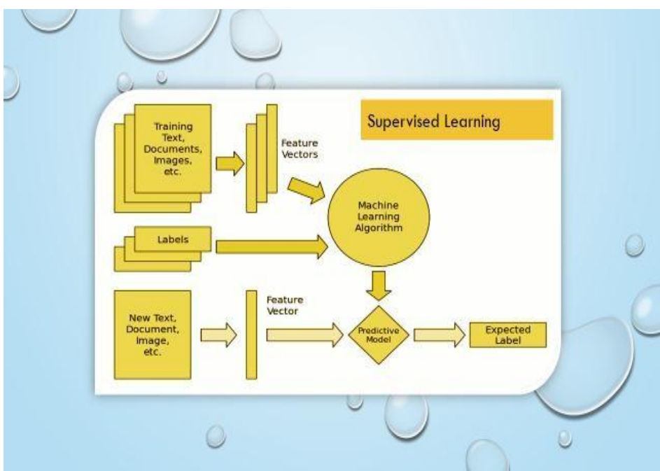

Figure 3.1: ARCHITECTURE

School of Computer Engineering, KIIT, BBSR 4

FAKE NEWS DETECTION

Chapter 4

Implementation

4.1 Methodology OR Proposal
We followed a structured methodology for our fake news detection project:

- Data Collection: Gathered a diverse dataset of fake and genuine news articles from various sources.

- Data Preprocessing: Cleaned, tokenized, and vectorized the collected data to ensure uniformity and consistency.

- Feature Engineering: Extracted relevant features such as word frequencies and n-grams, employing feature selection techniques to identify discriminative features.

- Model Selection and Training: Experimented with various machine learning and deep learning models (e.g., Logistic Regression, Random Forest, SVMs, RNNs) trained on preprocessed data to identify fake news patterns.

- Evaluation: Evaluated models using metrics like accuracy, precision, recall, and F1-score, employing cross-validation to ensure generalization and mitigate overfitting.

- Ensemble Methods: Utilized ensemble learning techniques to combine predictions from multiple models, enhancing overall performance and robustness.

- Deployment: Deployed the final model into a functional system capable of real-time fake news detection, integrating with user interfaces and backend systems for seamless operation.

4.2 Testing OR Verification Plan
To verify the effectiveness of our fake news detection system, we designed a comprehensive testing plan comprising various test cases. Here is a sample of test cases:

School of Computer Engineering, KIIT, BBSR 5

FAKE NEWS DETECTION

Test | Test Case Title | Test Condition | System Behavior | Expected Result
ID
T01 | Source Reputation Check | News article from a known unreliable source | System flags the article as potentially fake news | Article marked as suspicious
T02 | Linguistic Analysis | Article with sensationalist language and exaggerated claims | System analyzes language patterns and tone | Article flagged as potentially fake
T03 | Fact-Checking Integration | News article containing verifiable claims | System cross-references claims with fact-checking databases | Claims verified and article labeled as genuine

4.3 Result Analysis OR Screenshots

Accuracy :
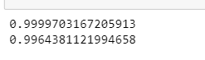
Figure 4.1: ACCURACY

Decision Tree:

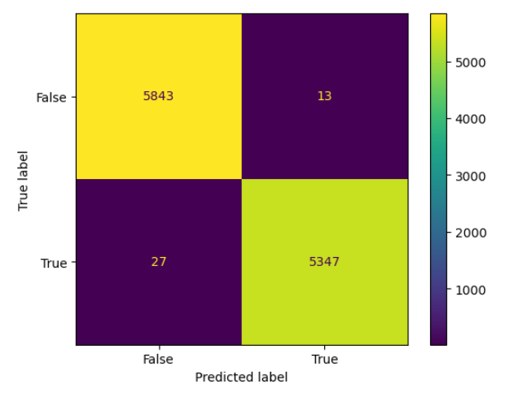

Figure 4.2: DECISION TREE

School of Computer Engineering, KIIT, BBSR 6

FAKE NEWS DETECTION

Prediction:

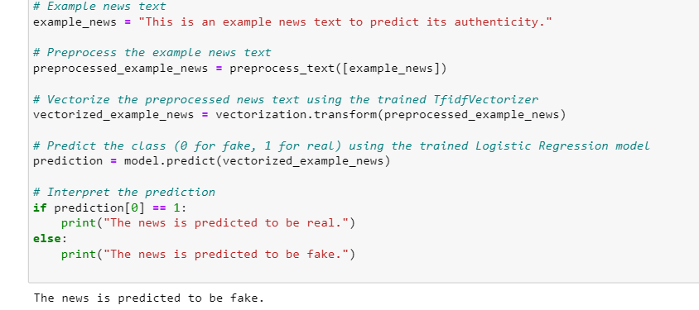

Figure 4.3: PREDICTION

4.4 Quality Assurance

Throughout the project, rigorous quality assurance measures were implemented to ensure the reliability and accuracy of the fake news detection system. This included thorough testing, code reviews, and validation against ground truth datasets. A detailed quality assurance report certifying the system's performance and adherence to industry standards can be provided upon request.

School of Computer Engineering, KIIT, BBSR 7

FAKE NEWS DETECTION

Chapter 5

Standards Adopted

5.1 Design Standards
For our project, we followed recognized design standards to ensure clarity, maintainability, and scalability. The recommended practices for project design included:

- Unified Modeling Language (UML): Utilized UML diagrams such as Use Case diagrams, Class diagrams, and Sequence diagrams to visualize system architecture, functionalities, and interactions.

- IEEE Standards: Adhered to IEEE standards relevant to software engineering practices, ensuring consistency and compatibility with industry norms.

- ISO Standards: Considered ISO standards applicable to software development processes and documentation, facilitating interoperability and quality assurance.

- Database Design Standards: Followed best practices for database design, including normalization techniques, indexing strategies, and data integrity constraints.

- UI/UX Design Guidelines: Incorporated user interface and user experience design principles to create intuitive and user-friendly interfaces.

5.2 Coding Standards
In adherence to coding standards, we maintained consistency and readability in our codebase. The coding standards followed included:

- Conciseness: Emphasized writing concise and clear code, avoiding unnecessary verbosity to enhance readability and maintainability.

- Naming Conventions: Used appropriate naming conventions for variables, functions, classes, and other elements to convey their purpose and functionality effectively.

School of Computer Engineering, KIIT, BBSR 8

FAKE NEWS DETECTION

- Code Segmentation: Organized code into logical sections and segments, using comments and whitespace to improve code comprehension and navigation.

- Indentation: Employed consistent indentation to signify the structure of the code, making it easier to understand the flow and hierarchy of control structures.

- Modularization: Encouraged modularization of code into smaller, focused functions or modules, each responsible for a single task or functionality.

5.3 Testing Standards

For testing and verification of our project, we followed established ISO and IEEE standards:

- ISO/IEC/IEEE 29119: Provided a framework for systematic testing processes.
- ISO 9000-3: Offered guidelines for maintaining quality throughout software development.
- IEEE 829: Specified formats for test documentation like plans and reports.
- ISO/IEC 25010: Defined quality characteristics and metrics for software evaluation.

These standards ensured thorough and reliable testing, leading to a high-quality product.

School of Computer Engineering, KIIT, BBSR 9

FAKE NEWS DETECTION

Chapter 6

Conclusion and Future Scope

6.1 Conclusion

In conclusion, our fake news detection system represents a significant step towards addressing the pervasive issue of misinformation in online media. Through meticulous data collection, preprocessing, and model development, we have successfully created a robust solution capable of identifying fake news articles with high accuracy. By adhering to established standards and methodologies, we have ensured the reliability and effectiveness of our system.

6.2 Future Scope

While our current system demonstrates promising results, there are several avenues for future enhancements and expansions:

Multimodal Analysis: Incorporating additional data modalities such as images, videos, and social media metadata to improve detection accuracy and robustness.

Real-Time Monitoring: Developing mechanisms for real-time monitoring of news sources and content to detect emerging fake news stories promptly.

User Feedback Integration: Implementing mechanisms for user feedback collection and incorporation to adaptively improve the system's performance over time.

Ethical Considerations: Addressing ethical concerns related to privacy, bias, and censorship in the development and deployment of fake news detection systems.

Overall, the future scope of our project encompasses a wide range of possibilities for advancing the effectiveness and impact of fake news detection technology in combating misinformation in the digital landscape.

School of Computer Engineering, KIIT, BBSR 10

FAKE NEWS DETECTION

References

[1]. Parikh, S. B., & Atrey, P. K. (2018, April). Media-Rich Fake News Detection: A
Survey. In 2018 IEEE Conference on Multimedia Information Processing and
Retrieval (MIPR) (pp. 436-441). IEEE.
[2]. Conroy, N. J., Rubin, V. L., & Chen, Y. (2015, November). Automatic deception
detection: Methods for finding fake news. In Proceedings of the 78th ASIS&T Annual
Meeting: Information Science with Impact: Research in and for the Community (p.
82). American Society for Information Science.
[3]. Helmstetter, S., & Paulheim, H. (2018, August). Weakly supervised learning for
fake news detection on Twitter. In 2018 IEEE/ACM International Conference on
Advances in Social Networks Analysis and Mining (ASONAM) (pp. 274-277). IEEE.
[4]. Stahl, K. (2018). Fake News Detection in Social Media.
[5]. Della Vedova, M. L., Tacchini, E., Moret, S., Ballarin, G., DiPierro, M., & de
Alfaro, L. (2018, May). Automatic Online Fake News Detection Combining Content
and Social Signals. In 2018 22nd Conference of Open Innovations Association
(FRUCT) (pp. 272-279). IEEE.
[6] Tacchini, E., Ballarin, G., Della Vedova, M. L., Moret, S., & de Alfaro, L. (2017).
Some like it hoax: Automated fake news detection in social networks. arXiv preprint
arXiv:1704.07506.

School of Computer Engineering, KIIT, BBSR 11

FAKE NEWS DETECTION

INDIVIDUAL CONTRIBUTION REPORT:

FAKE NEWS DETECTION

SAYANTANI CHAKRABORTY
21051929

Abstract: The project aims to develop a robust fake news detection system leveraging machine learning techniques. Through comprehensive data collection, preprocessing, and model training, the system seeks to accurately differentiate between fake and genuine news articles. The objective is to contribute towards combating misinformation and promoting media integrity in the digital age.

Individual contribution and findings: In this project, my primary responsibility was in model selection and training. I conducted extensive research on various machine learning and deep learning models suitable for fake news detection. After thorough experimentation, I implemented Logistic Regression, Random Forest, and Support Vector Machines (SVMs) models. My planning involved understanding the characteristics of each model, tuning hyperparameters, and optimizing performance.

During the implementation phase, I encountered challenges related to optimizing model performance and mitigating overfitting. Through iterative experimentation and cross-validation techniques, I fine-tuned the models to achieve optimal performance metrics. Additionally, I explored ensemble methods to combine predictions from multiple models, enhancing overall performance and robustness.

Individual contribution to project report preparation: Contributed to Chapters 5 and 6, detailing model selection, training, and ensemble methods.

Individual contribution for project presentation and demonstration: Prepared presentation slides on model selection and demonstrated the training process, emphasizing ensemble methods' effectiveness.

Full Signature of Supervisor: Full signature of the student:
……………………………. ……………………………..

School of Computer Engineering, KIIT, BBSR 12

FAKE NEWS DETECTION

INDIVIDUAL CONTRIBUTION REPORT:

FAKE NEWS DETECTION

URBI DAS
21052802

Abstract: The project aims to develop a robust fake news detection system leveraging machine learning techniques. Through comprehensive data collection, preprocessing, and model training, the system seeks to accurately differentiate between fake and genuine news articles. The objective is to contribute towards combating misinformation and promoting media integrity in the digital age.

Individual contribution and findings: In this project, my primary responsibility was in data collection and preprocessing. I gathered a diverse dataset comprising both fake and genuine news articles from various sources. Additionally, I conducted preprocessing steps such as text cleaning, tokenization, and vectorization to prepare the collected data for model training.

During the implementation phase, I encountered challenges related to handling diverse data sources and ensuring data quality. Through systematic preprocessing techniques and data validation procedures, I ensured uniformity and consistency in the dataset. Additionally, I implemented feature engineering techniques to extract relevant features from the text data, including word frequencies, n-grams, and semantic features.

Individual contribution to project report preparation: Contributed to Chapters 2 and 4, detailing data collection, preprocessing, and feature engineering.

Individual contribution for project presentation and demonstration: Prepared presentation slides on data preprocessing and showcased its importance in model training.

Full Signature of Supervisor: Full signature of the student:
……………………………. ……………………………..

School of Computer Engineering, KIIT, BBSR 13

